Activity 1.1.1 Simple Machine Investigation – VEX

Introduction
Greek mathematician, physicist, astronomer, and engineer Archimedes boasted, “Give me a place to stand, and with a lever I will move the whole world.” Archimedes never moved the world, but he did change the world through the development of simple machine mechanisms.

In this activity you will explore the function and characteristics of the lever, wheel and axle, and pulley systems. You will see firsthand how simple machines manipulate energy to create a desired output.

Equipment
- POE VEX kit components
- Rulers and/or tape measures
- String – Masonry line
- Vernier Interface
- Vernier Dual-Range Force Sensor
- Vernier LoggerPro software
Procedure
For this activity your team of four will construct simple machines using VEX components. After you have constructed the simple machines, you will gather data to calculate mechanical advantage. It is important to be as accurate as possible in your measurements and documentation.

Terms to know to complete this activity:

The Effort (F_{E}) is the force that you apply to the system.

The Resistance (F_{R}) is the force or load that you are manipulating.

Part 1 – Lever, Wheel and Axle, and Pulley
First Class Lever

- Create a scaled annotated drawing of the first class lever.

- Calculate the ideal mechanical advantage of the lever system.
Formula | Substitute / Solve | Final Answer

- Calculate the ideal effort force needed to overcome the known resistance force.
Formula | Substitute / Solve | Final Answer

- Calculate the actual mechanical advantage of the lever system.
Formula | Substitute / Solve | Final Answer

- Calculate the efficiency of the lever system.
Formula | Substitute / Solve | Final Answer
- List and describe two examples of a first class lever.

Second Class Lever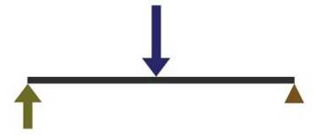
- Create a scaled annotated drawing of the second class lever.

- Calculate the ideal mechanical advantage of the lever system.
Formula | Substitute / Solve | Final Answer

- Calculate the ideal effort force needed to overcome the known resistance force.
Formula | Substitute / Solve | Final Answer

- Calculate the actual mechanical advantage of the lever system.
Formula | Substitute / Solve | Final Answer

- Calculate the efficiency of the lever system.
Formula | Substitute / Solve | Final Answer
- List and describe two examples of a second class lever.

.
Third Class Lever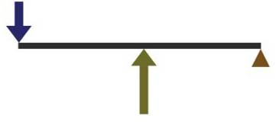

- Create a scaled annotated drawing of the third class lever.

- Calculate the ideal mechanical advantage of the lever system.
Formula | Substitute / Solve | Final Answer

- Calculate the ideal effort force needed to overcome the known resistance force.
Formula | Substitute / Solve | Final Answer

- Calculate the actual mechanical advantage of the lever system.
Formula | Substitute / Solve | Final Answer

- Calculate the efficiency of the lever system.
Formula | Substitute / Solve | Final Answer
- List and describe two examples of a third class lever.

- Is it possible for a first or second class lever to have a mechanical advantage less than one, or for a third class lever to have a mechanical advantage greater than one? Justify your answer.

- When you were solving for mechanical advantage, what units did the final answer require? Explain why.

Wheel and Axle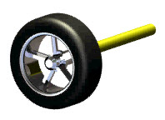

- What is the diameter of the wheel?

- What is the diameter of the axle?

- Attach the resistance weight to the string attached to the axle. Use your fingers to turn the wheel. Based on where the applied effort and resistance are located, identify the distance traveled by both forces during one full rotation.
D_{E} =
D_{R} =

- Remove the resistance weight from the axle string and attach the weight to the wheel. Use your fingers to turn the axle. Based on where the applied effort and resistance are located, identify the distance traveled by both forces during one full rotation.
D_{E} =
D_{R} =

- Wrap the resistance weight around the axle using string. Use the force sensor attached to the string wrapped around the wheel to create equilibrium. Based on where the applied effort and resistance are located, identify the force required to hold the system in equilibrium.
F_{E} =
F_{R} =

- Wrap the weight around the wheel using string. Use the force sensor attached to string on the axle to create equilibrium. Based on where the applied effort and resistance are located, identify the force required to hold the system in equilibrium.
F_{E} =
F_{R} =

- For the same resistance, is the effort force larger when the effort is applied to the wheel or when it is applied to the axle? Explain why.

- Create a scaled annotated drawing of the wheel and axle system.
- Calculate the ideal mechanical advantage of the wheel and axle system if the resistance force is applied to the axle.
Formula | Substitute / Solve | Final Answer

- Calculate the ideal mechanical advantage of the wheel and axle system if the resistance force is applied to the wheel.
Formula | Substitute / Solve | Final Answer

- Calculate the ideal effort force needed to overcome the known resistance force if the resistance force is applied to the wheel.
Formula | Substitute / Solve | Final Answer

- Calculate the actual mechanical advantage of your wheel and axle system if the resistance force is applied to the wheel.
Formula | Substitute / Solve | Final Answer

- Calculate the efficiency of the wheel and axle system when the resistance force is applied to the wheel.
Formula | Substitute / Solve | Final Answer

- List and describe two examples of a wheel and axle.

- If you know the dimensions of a wheel and axle system used for an automobile, how can you determine the distance covered for each axle revolution? Explain any additional information and necessary formulas.

- Why is the steering wheel on a school bus so large?

Fixed Pulley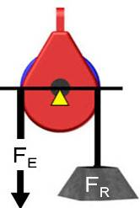

- Create a scaled annotated drawing of the fixed pulley system.

- Calculate the ideal mechanical advantage of the fixed pulley system.
Formula | Substitute / Solve | Final Answer

- Calculate the actual mechanical advantage of the fixed pulley system.
Formula | Substitute / Solve | Final Answer

Calculate the efficiency of the fixed pulley system.
Formula | Substitute / Solve | Final Answer

Movable Pulley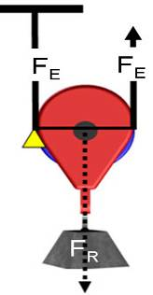

- Create a scaled annotated drawing of the pulley system.
- Calculate the actual mechanical advantage of the pulley system.
Formula | Substitute / Solve | Final Answer

- Calculate the ideal mechanical advantage of the pulley system.
Formula | Substitute / Solve | Final Answer

- Calculate the efficiency of the fixed pulley system.
Formula | Substitute / Solve | Final Answer

Block and Tackle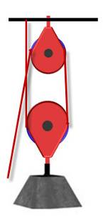

- Create a scaled annotated drawing of the pulley system.

- Calculate the actual mechanical advantage of the pulley system.
Formula | Substitute / Solve | Final Answer

- Calculate the ideal mechanical advantage of the pulley system.
Formula | Substitute / Solve | Final Answer

- Calculate the efficiency of the fixed pulley system.
Formula | Substitute / Solve | Final Answer

- Describe two examples of a pulley system.

- The fixed pulley contained two strands. Explain the role of each strand.

- The movable pulley contained two strands. Explain the role of each strand.

- In the block and tackle system, explain how mechanical advantage relates to the number of strands.

- In a block and tackle system with a mechanical advantage of 3, the effort is measured at 15 lbf. The resistance, when balanced, is measured at 42 lbf. What factors might account for the loss in energy?

Part 2 – Inclined Plane and Screw
Inclined Plane 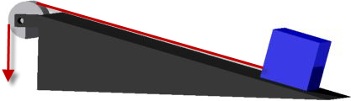

- Create a scaled annotated drawing of the inclined plane system.

- Calculate the ideal mechanical advantage of the inclined plane system.
Formula | Substitute / Solve | Final Answer

- Calculate the ideal effort force needed to overcome the known resistance force.
Formula | Substitute / Solve | Final Answer

- Calculate the actual mechanical advantage of the inclined plane system.
Formula | Substitute / Solve | Final Answer

- Calculate the efficiency of the inclined plane system.
Formula | Substitute / Solve | Final Answer

- List and describe two examples of an inclined plane.

Screw 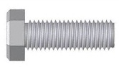

- Create a scaled annotated drawing of the screw system.

- Calculate the ideal mechanical advantage of the screw.
Formula | Substitute / Solve | Final Answer

- Calculate the ideal effort force needed to overcome the known resistance force.
Formula | Substitute / Solve | Final Answer

- Calculate the actual mechanical advantage of the screw.
Formula | Substitute / Solve | Final Answer

- Calculate the efficiency of the screw.
Formula | Substitute / Solve | Final Answer

- Describe two examples of a screw.

- Why do you think overcoming a resistance force using a screw is so easy?

- The screw is a combination of two simple machines. Identify and defend what two simple machines you believe are combined to create a screw.

